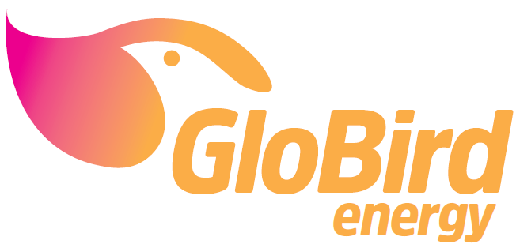

Date Issued: 26/02/2020

<<Account Number>>

<<First Name>><<Surname>>

<<Address>>

<<Suburb>>

<<State>><<Postcode>>

**IMPORTANT: Life Support Equipment Register Notice**

As part of a crucial safety review, GloBird is contacting all customers who are flagged as having life support equipment at their premises.

As your energy provider it is a vital part of our Life Support Program that we hold valid and up to date information about your life support status and equipment you require so we can respond appropriately.

In order to continue the protections of our Life Support Program, you must fill out the attached ***Life Support Equipment Acknowledgement Form***. Please email the completed form to [**customerservice@globirdenergy.com.au**](mailto:customerservice@globirdenergy.com.au) or return it to: **PO BOX 398 Ringwood 3134 Victoria.**

Alternatively, it is important that you let us know if you no longer require life support protection or if this site no longer needs to be flagged as having a life support machine by marking the below ***Life Support Equipment Acknowledgement Form*** as “NO”.

Please return the form within 10 business days.

**Failing to return the appropriate form may result in your site having any protections for life support removed.**

If you have any questions or require assistance, please give us a call on 133 456 Monday – Friday 8:30 AM to 5:30 PM.

Regards,

From Globird Energy Customer Service Team

**Life Support Equipment Acknowledgement Form**

Please complete the details below and return it to **PO BOX 398 Ringwood 3134 Victoria** or email it to **customerservice@globirdenergy.com.au**

|  |  |
| --- | --- |
| Information required | Updated details |
| Is life support equipment still used at:  «acct_number»  «sup_Unit» «sup_addr_1»  «sup_addr_2»  «sup_addr_3» | **Is Life Support Equipment Required?**  YES  (If you tick this box, Globird will check to see if we have your current signed **Medical Confirmation Form otherwise, we will be in touch with you soon**)  NO  (If you tick this box, we may unflag this site as requiring life support protections, please call Globird on 133456 or return this **Life Support Equipment Acknowledgement Form**) |

The information above is deemed to be true and correct and I give my permission for Globird Energy to contact me if required.

Signature: _________________________________________________

Print Name: ________________________________________________

Date: ______________________________________________________